/Users/cesargarcia/Downloads/learntoprogramlogo.png

**Javascript Specialist Designation Program**

Lab Exercise #1

The purpose of the included lab exercises is to assist you in applying and retaining the information in the video lecture. These lab exercises are a very important facet of your learning. You can’t learn to ride a bicycle by watching an instructor talk about it. You have to physically get on the bike and ride!

<!DOCTYPE html>

<html>

<head>

<title>Lab #1</title>

</head>

<body>

</body>

<html>

**Lab Instructions**

1) Create an empty folder on your Desktop and name it **Javascript Specialist.**

If you haven’t yet downloaded Brackets do so now from [**www.brackets.io**](http://www.brackets.io).

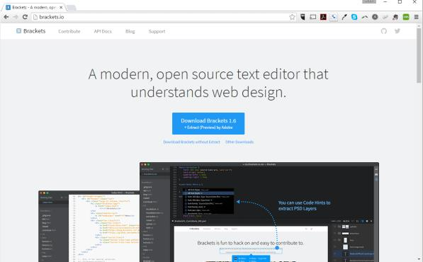

Once you’ve downloaded and installed the software start it up.

2) With Brackets running, choose File →New to open a new document. You should see the cursor flashing on the first line.

3) Immediately save your document using File →Save from the drop-down menus. Navigate to the **Javascript Specialist** folder on your Desktop and save your lab under the file name **first_javascript_lab.html**.

Saving your lab at this point will allow you to take advantage of the syntax highlighting features available in brackets.

4) Usually, Javascript lives in or around HTML. We need to create a very basic web page and display it in the web browser. First you will need to key in the basic document structure. Be careful to key in the HTML5 code below exactly as it appears.

We’re using **Lab #1** as the content for the title tag in this case.

5) In the body of the document add a heading 1 tag with the content “She sells seashells by the seashore.” Your code should look like this:

<h1>She sells seashells by the seashore.</h1>

6) Now we’re going to add two buttons that will interact with Javascript. Using a button tag, placed after the previous <h1> tag, add a “Click me to output to console!” message. Then, add another button with the message “Click me to output to the browser!”. Afterwards, give each element an id of “consoleButton” and “browserButton”. Your code should look something like this:

<button id="consoleButton">Click me to output to the console!</button>

<button id="browserButton">Click me to output to the browser!</button>

7) Remember – There are 3 ways to use Javascript with HTML:

1. Inline Javascript – Not recommended.
2. Script tag within the HTML file itself.
3. A separate Javascript file – Best way!

Let’s go ahead and create a separate Javascript file. Within the Brackets editor, click File →New.

Immediately save your document using File →Save from the drop-down menu. Save under the file name **main.js**.

8) Create a script tag right above the body tag and link it to the Javascript file.

<script src="main.js"><script>

The HTML file is now aware of the Javascript file that exists within the folder.

9) Open your **main.js** file and create the window.onload function. This function will run as soon as the HTML file loads.

Inside the window.onload function, you will add two functions. The first function will grab the document, search for an element with an id of “consoleButton”, and wait for a specific event. Your code should look something like this:

window.onload = function() {

document.getElementById("consoleButton"  
).addEventListener("click", firstResponse);

};

(Remember, addEventListener is one word)

After this function, go ahead and type out the second function which will search for an element with the id “browserButton”. The event listener will call a function name “secondResponse”.

10) The response functions have not yet been created, so let’s go ahead and create the response functions that will output a message to either the console or browser.

function firstResponse(e) {

console.log("Thanks for clicking the console button!")

}

function secondResponse(e) {

document.write("Thanks for clicking the browser button!")

}

Your code should look something like this:

window.onload = function() {

document.getElementById("consoleButton").addEventListener("click", firstResponse);

document.getElementById("browserButton").addEventListener("click", secondResponse);

};

function firstResponse(e) {

console.log("Thanks for clicking the console button!")

}

function secondResponse(e) {

document.write("Thanks for clicking the browser button!")

}

10) Click File→Save to save the current version of your document. Navigate to the HTML document using your operating system and double click it. The document should open in your default browser.

Click each button and watch the messages pop up!

**Challenge Yourself**

Enhance your skills by attempting the exercises below.

1) Create a button and add a function to it that will give an alert when clicked.

2) Put your site on the web. We’ve arranged a special deal with Blue Host. Visit **http://www.bluehost.com/track/learntoprogra m/** and click “Get Stated Now.” You will be able to access web hosting plans as low as $3.49 a month. Once Blue Host takes you through the process of creating your domain and web server upload your lab and post the URL for the others in the class to see.